**BANK LOAN REPORT QUERY DOCUMENT**

1. **BANK LOAN REPORT | SUMMARY**

**KPI’s:**

**Total Loan Applications**

select count(id) as total_application from financial_loan

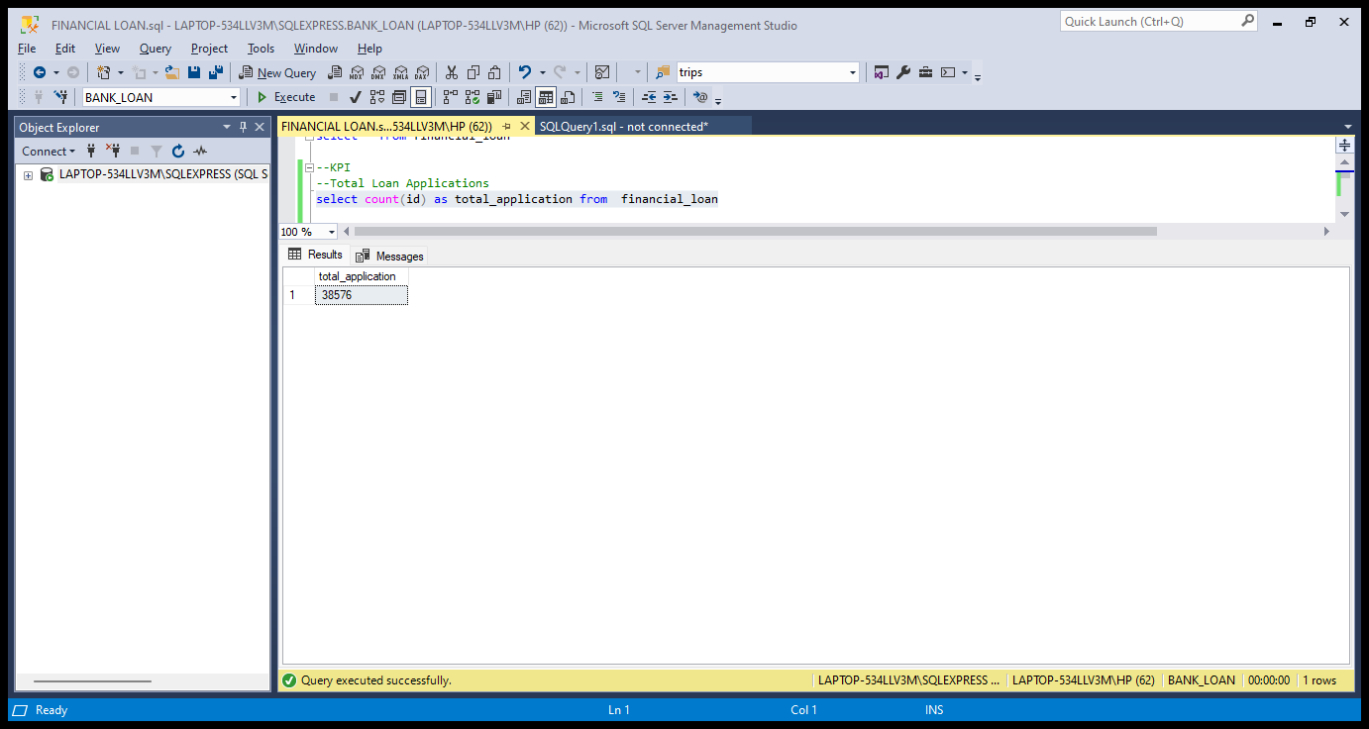

**MTD Loan Applications**

select count(id) as MTD_total_application from financial_loan where month(issue_date)=12 and YEAR(issue_date)=2021

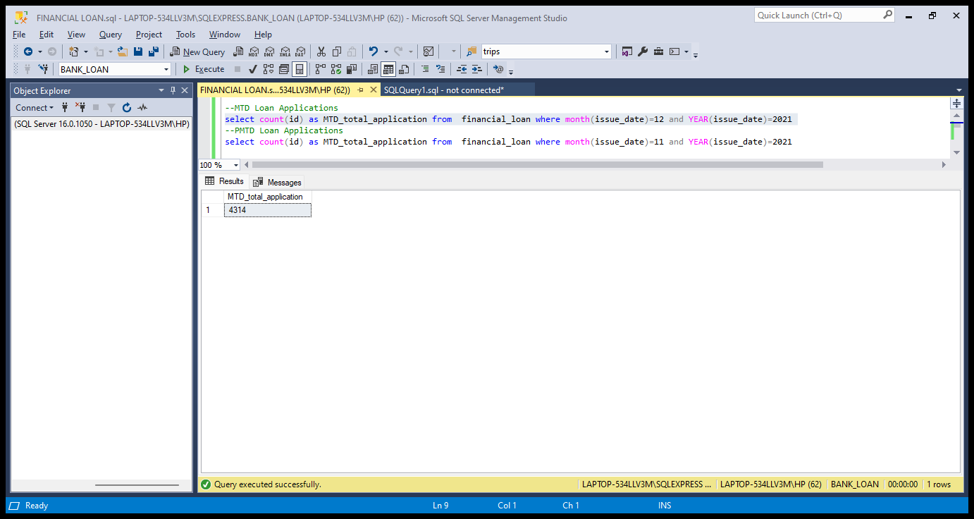

**PMTD Loan Applications**

select count(id) as MTD_total_application from financial_loan where month(issue_date)=11 and YEAR(issue_date)=2021

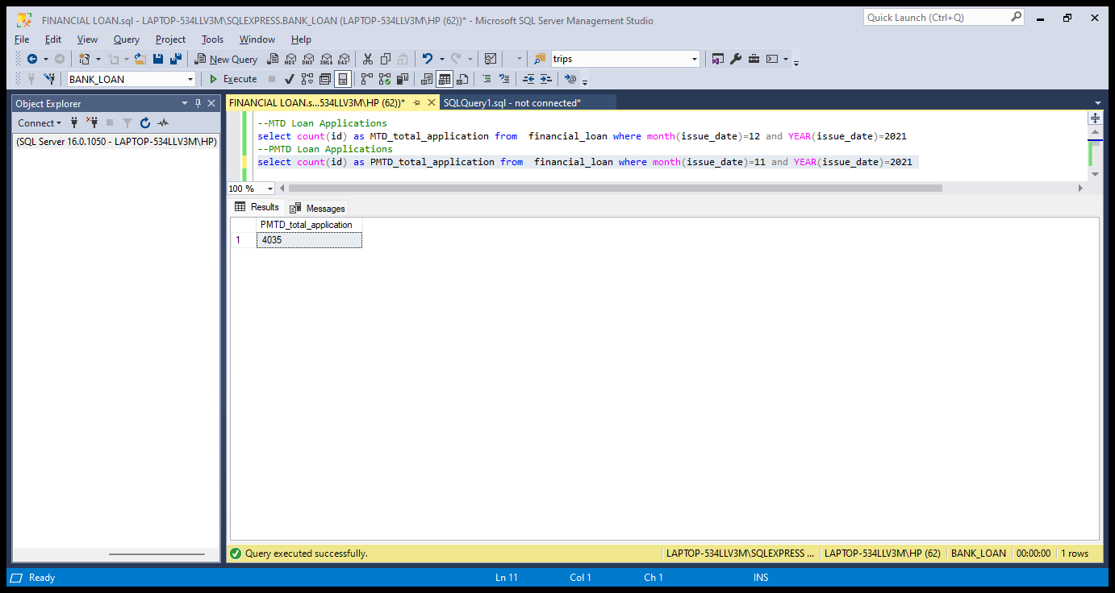

**Total Funded Amount**

SELECT SUM(loan_amount) AS TOTAL_FUNDED_AMOUNT FROM financial_loan



**MTD Total Funded Amount**

SELECT SUM(loan_amount) AS TOTAL_MONTH_WISE_FUNDED_AMOUNT FROM financial_loan WHERE MONTH(issue_date)=12 AND YEAR(issue_date)=2021

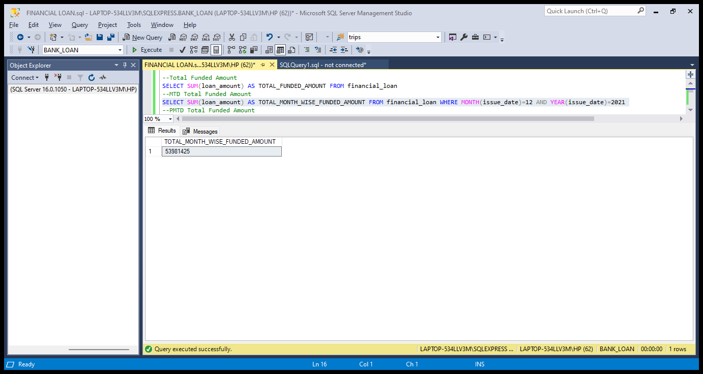

**PMTD Total Funded Amount**

SELECT SUM(loan_amount) AS TOTAL_PRE_MONTH_WISE_FUNDED_AMOUNT FROM financial_loan WHERE MONTH(issue_date)=11 AND YEAR(issue_date)=2021

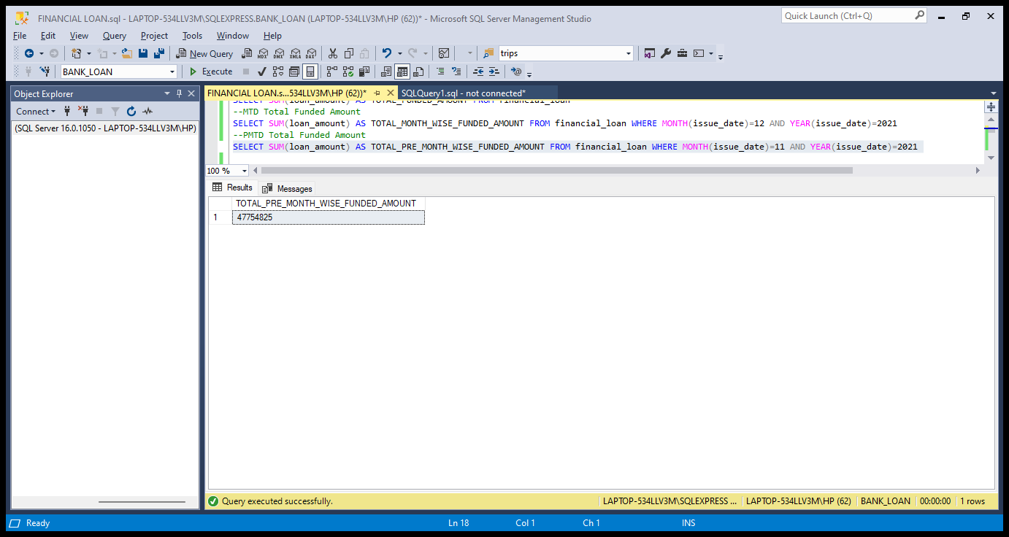

**Total Amount Received**

SELECT SUM(total_payment) AS TOTAL_AMOUNT_RECEIVED FROM financial_loan

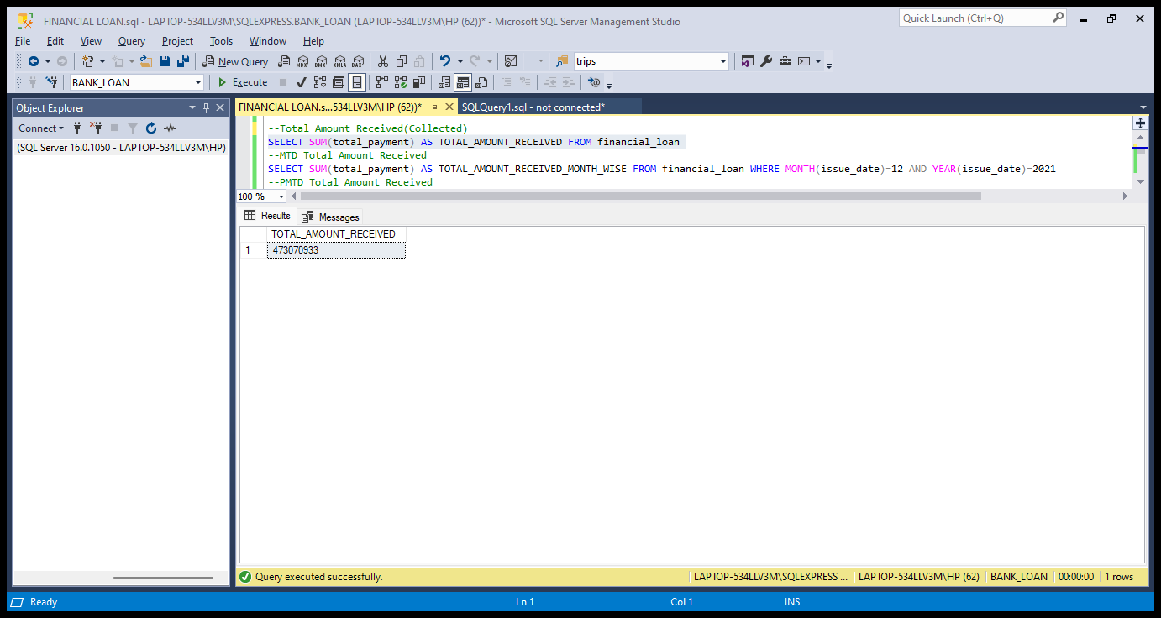

**MTD Total Amount Received**

SELECT SUM(total_payment) AS TOTAL_AMOUNT_RECEIVED_MONTH_WISE FROM financial_loan WHERE MONTH(issue_date)=12 AND YEAR(issue_date)=2021

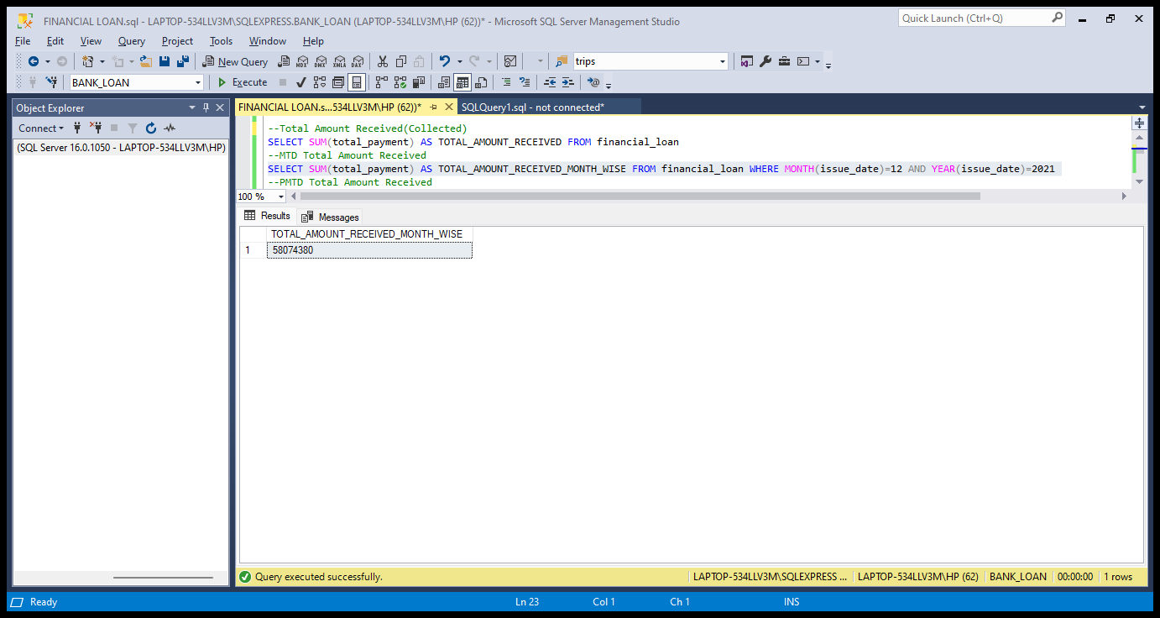

**PMTD Total Amount Received**

SELECT SUM(total_payment) AS TOTAL_AMOUNT_RECEIVED_PRE_MONTH_WISE FROM financial_loan WHERE MONTH(issue_date)=11 AND YEAR(issue_date)=2021

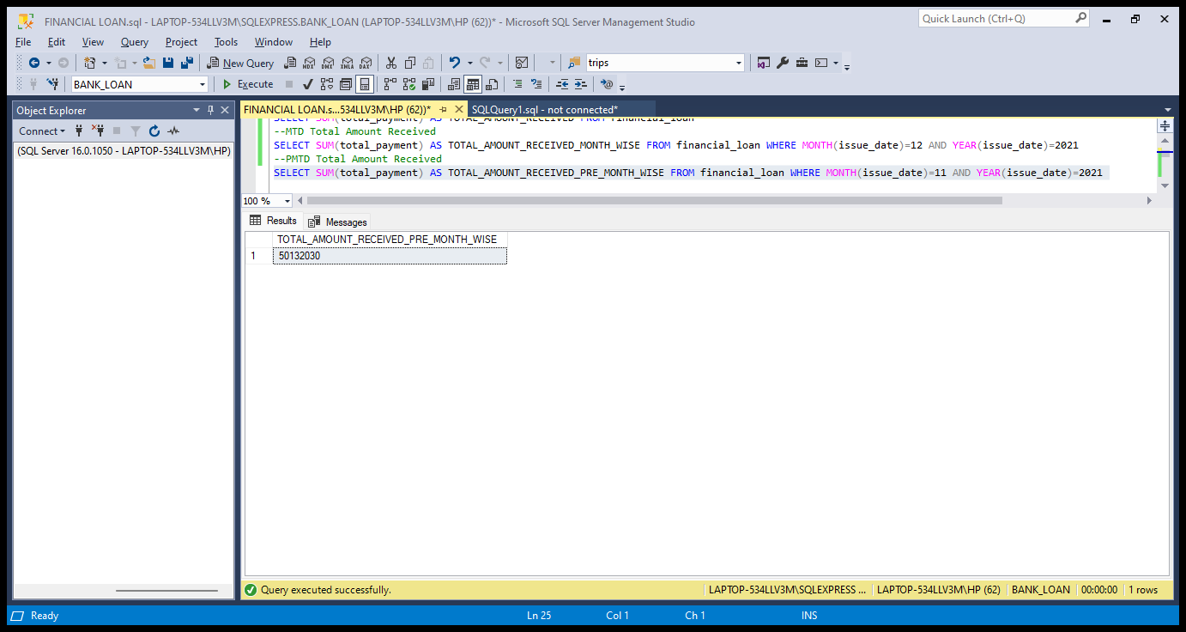

**Average Interest Rate**

SELECT ROUND(AVG(int_rate),4)*100 AS INTEREST_RATE FROM financial_loan

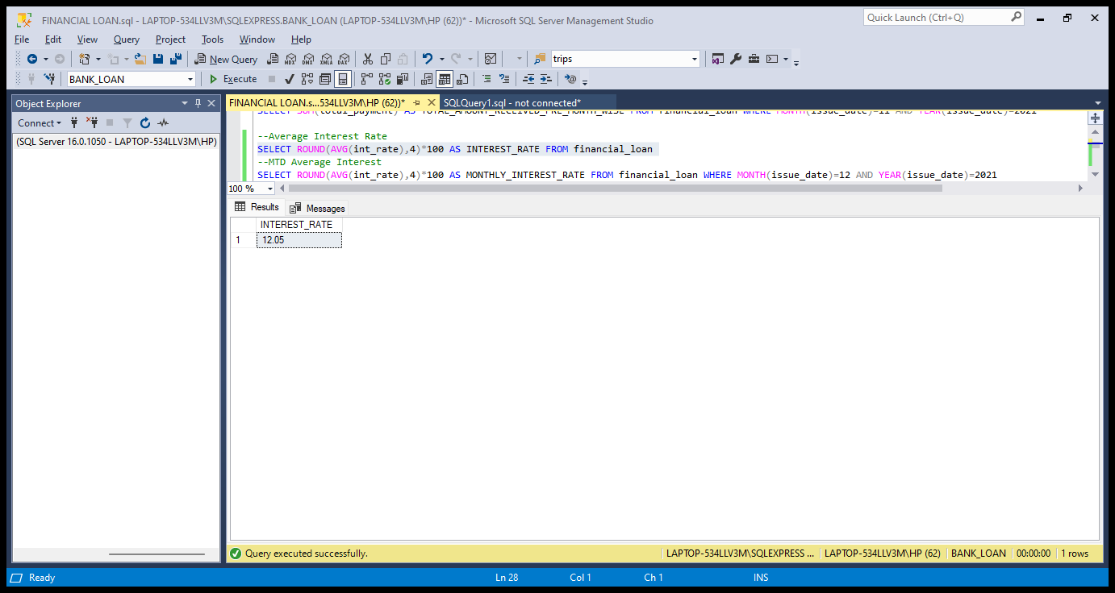

**MTD Average Interest**

SELECT ROUND(AVG(int_rate),4)*100 AS MONTHLY_INTEREST_RATE FROM financial_loan WHERE MONTH(issue_date)=12 AND YEAR(issue_date)=2021

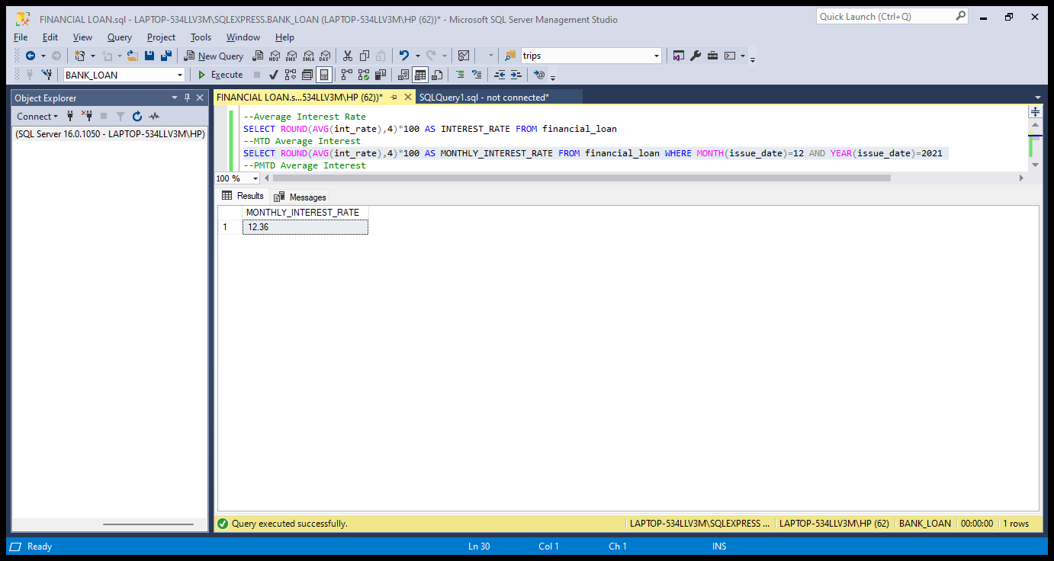

**PMTD Average Interest**

SELECT ROUND(AVG(int_rate),4)*100 AS PRE_MONTH_INTEREST_RATE FROM financial_loan WHERE MONTH(issue_date)=11 AND YEAR(issue_date)=2021

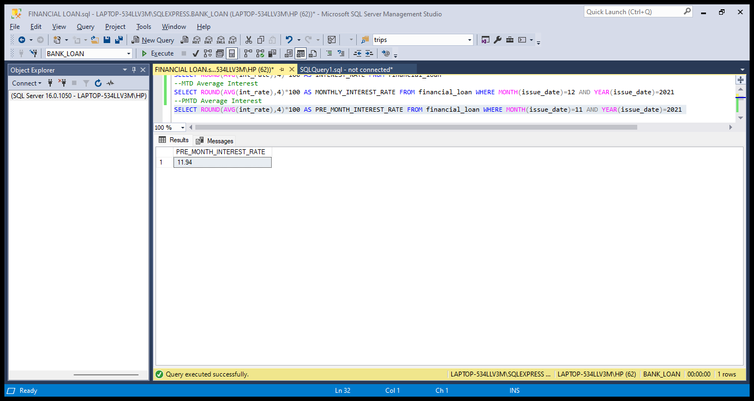

**Avg DTI**

SELECT ROUND(AVG(dti),4)*100 AS DTI_RATE FROM financial_loan

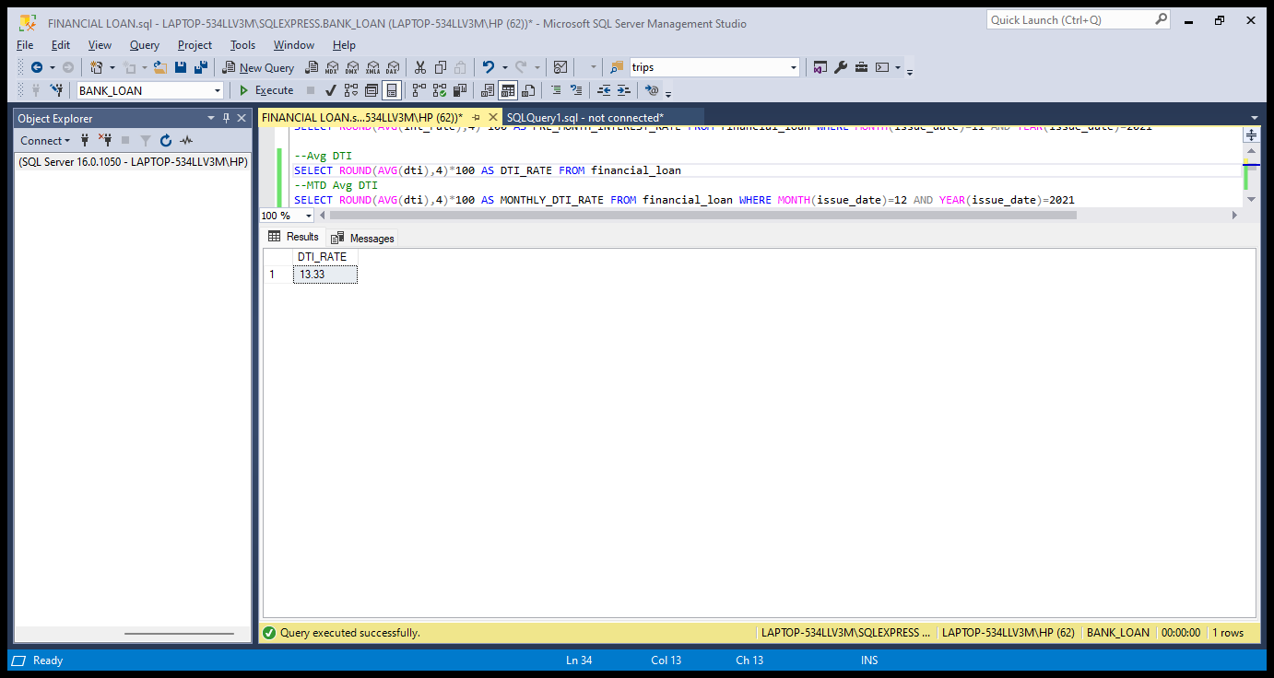

**MTD Avg DTI**

SELECT ROUND(AVG(dti),4)*100 AS MONTHLY_DTI_RATE FROM financial_loan WHERE MONTH(issue_date)=12 AND YEAR(issue_date)=2021

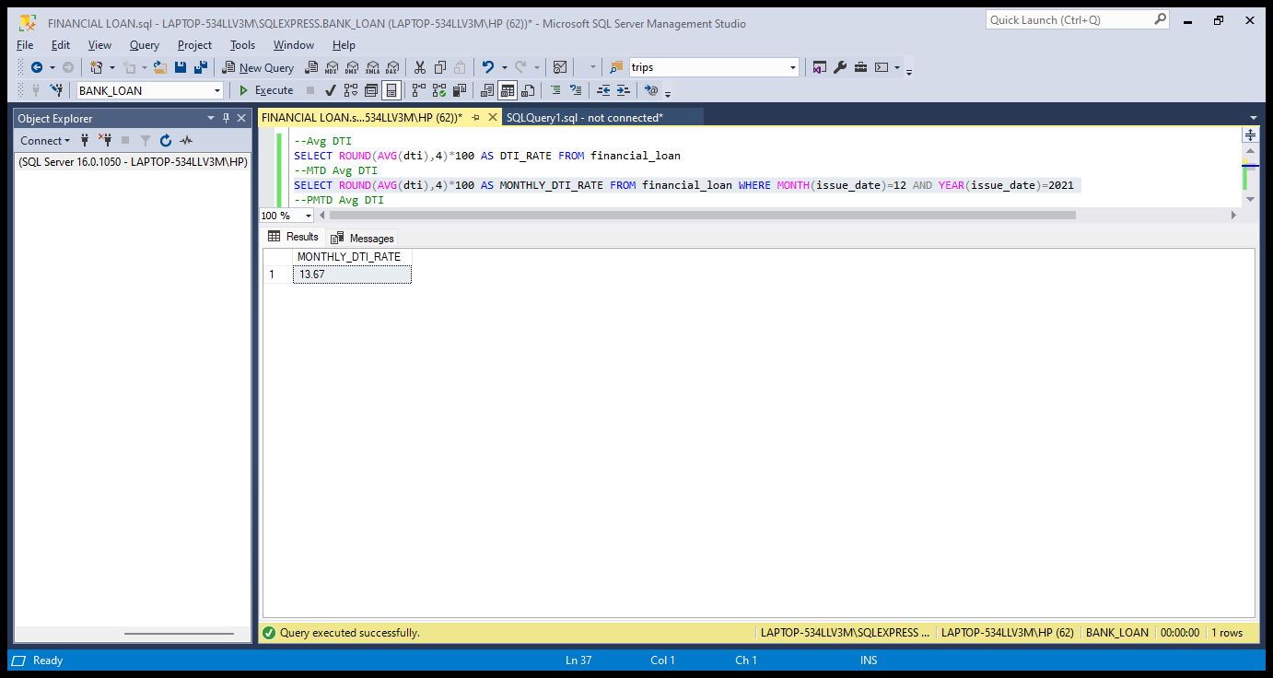

**PMTD Avg DTI**

SELECT ROUND(AVG(dti),4)*100 AS PRE_MONTH_DTI_RATE FROM financial_loan WHERE MONTH(issue_date)=11 AND YEAR(issue_date)=2021

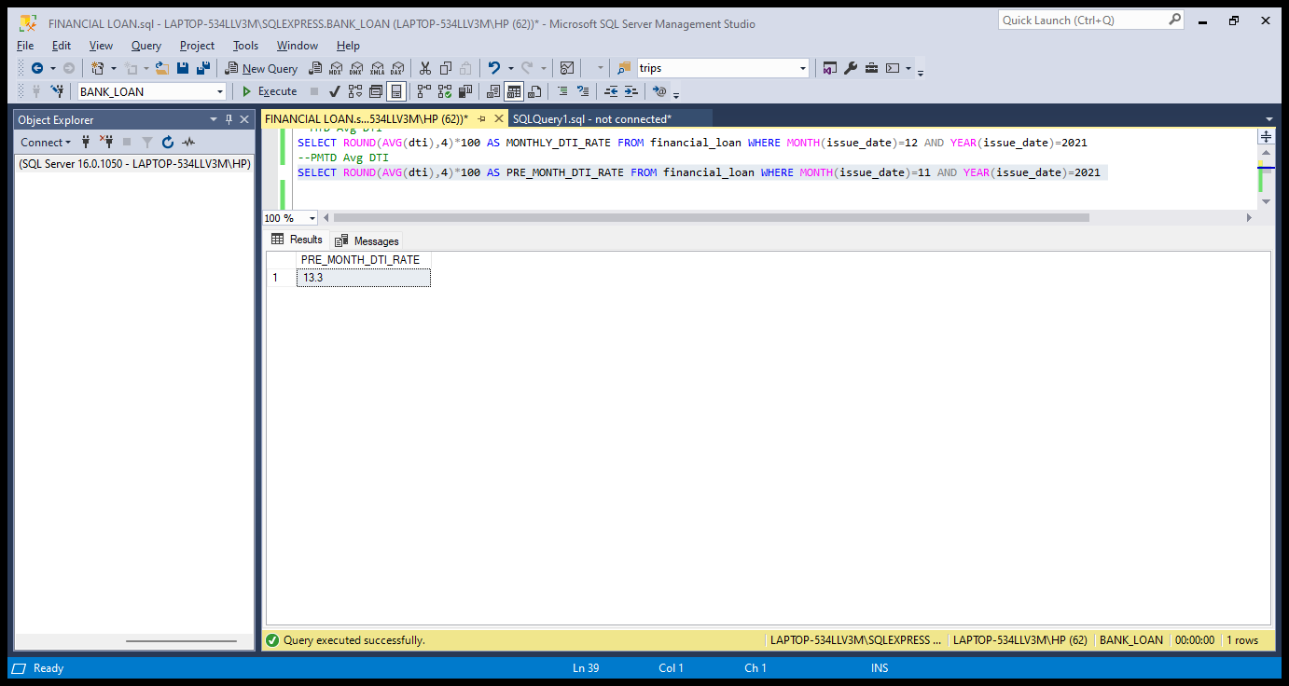

**GOOD LOAN ISSUED**

**Good Loan Percentage**

SELECT (COUNT(CASE WHEN loan_status='Fully Paid' OR loan_status='Current' THEN id END)*100)

/

COUNT(id) AS GOOD_LOAN_PERCENTAGE

FROM financial_loan

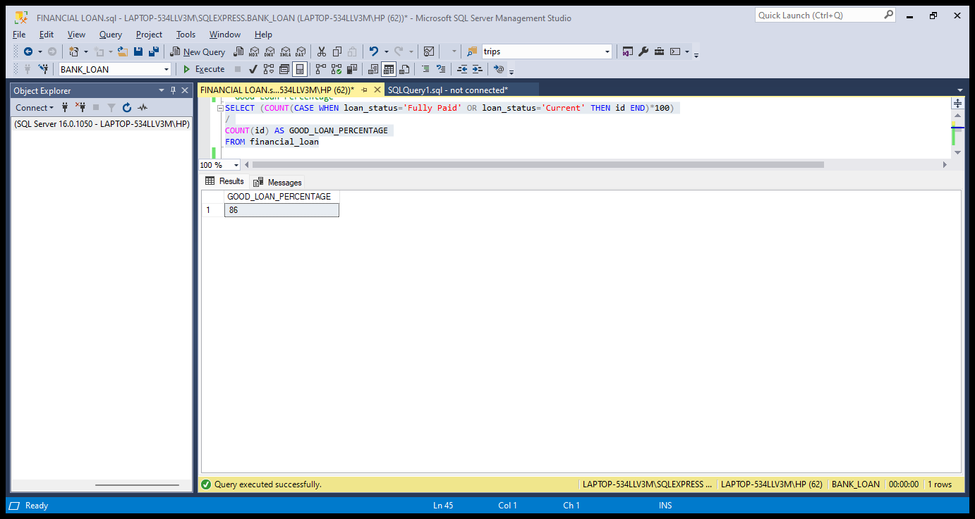

**Good Loan Applications**

SELECT COUNT(id) as good_loan_application FROM financial_loan WHERE loan_status='Fully Paid' OR loan_status='Current'

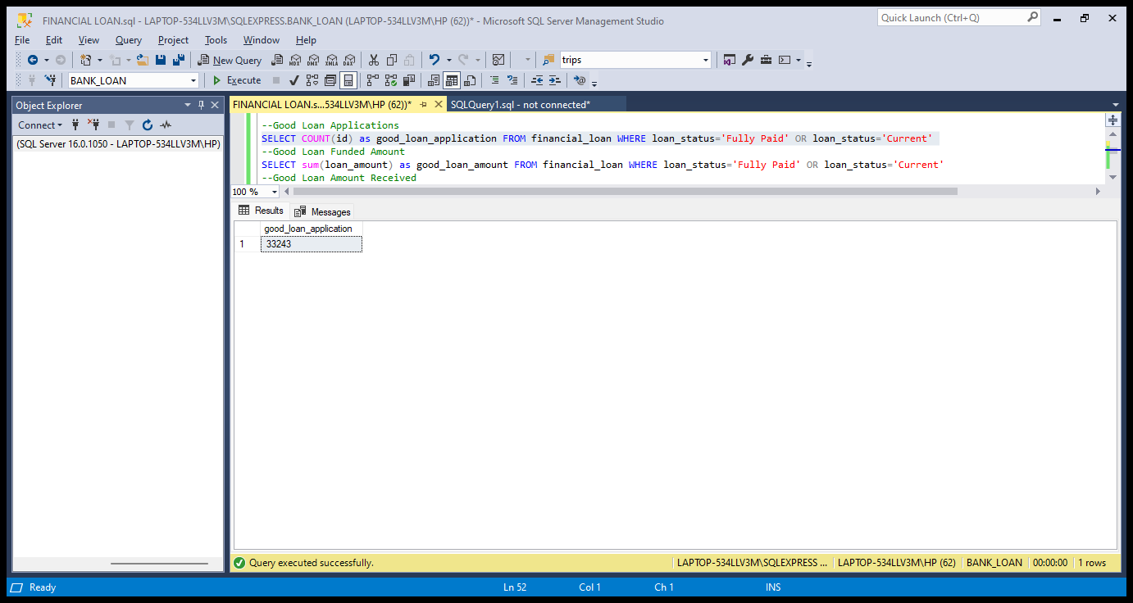

**Good Loan Funded Amount**

SELECT sum(loan_amount) as good_loan_amount FROM financial_loan WHERE loan_status='Fully Paid' OR loan_status='Current'

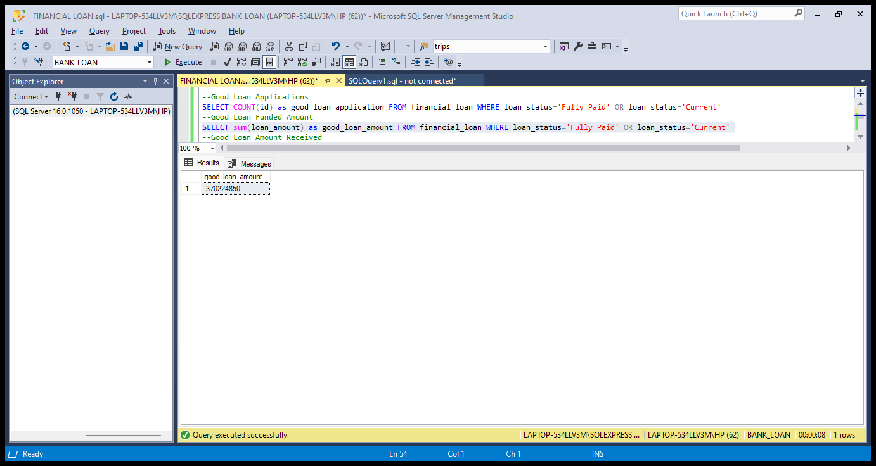

**Good Loan Amount Received**

SELECT sum(total_payment) as good_loan_recived_amount FROM financial_loan WHERE loan_status='Fully Paid' OR loan_status='Current'

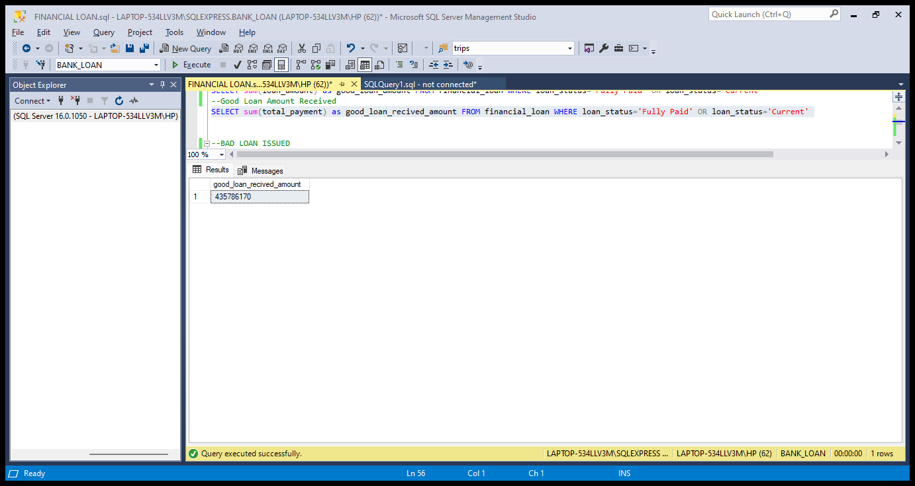

**BAD LOAN ISSUED**

**Bad Loan Percentage**

SELECT (COUNT(CASE WHEN loan_status='Charged Off' THEN id END)*100)

/

COUNT(id) AS BAD_LOAN_PERCENTAGE

FROM financial_loan

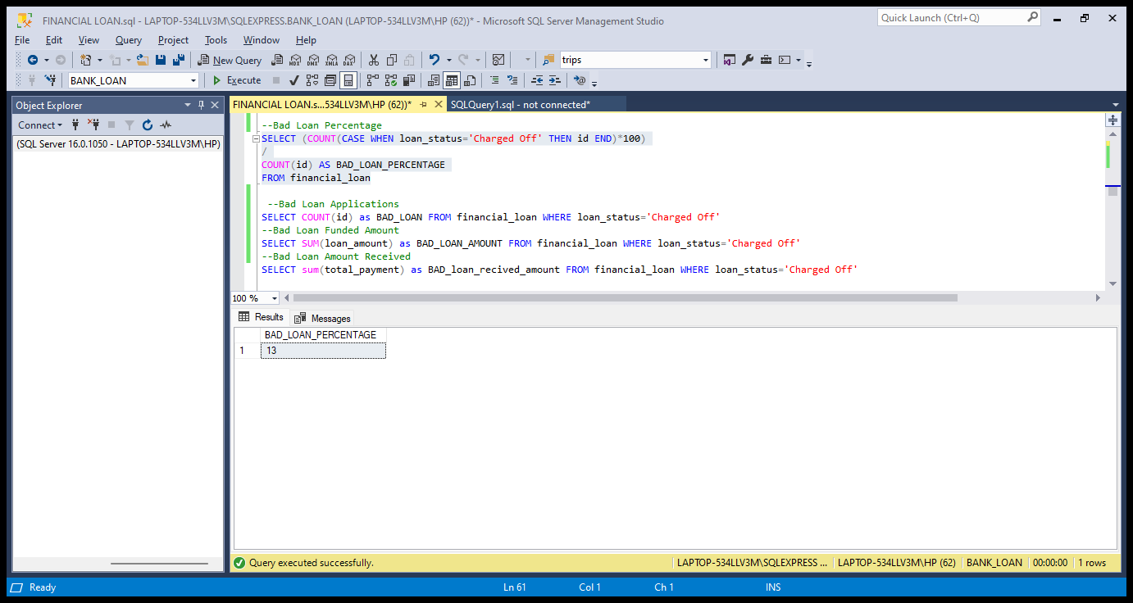

**Bad Loan Applications**

SELECT COUNT(id) as BAD_LOAN FROM financial_loan WHERE loan_status='Charged Off'

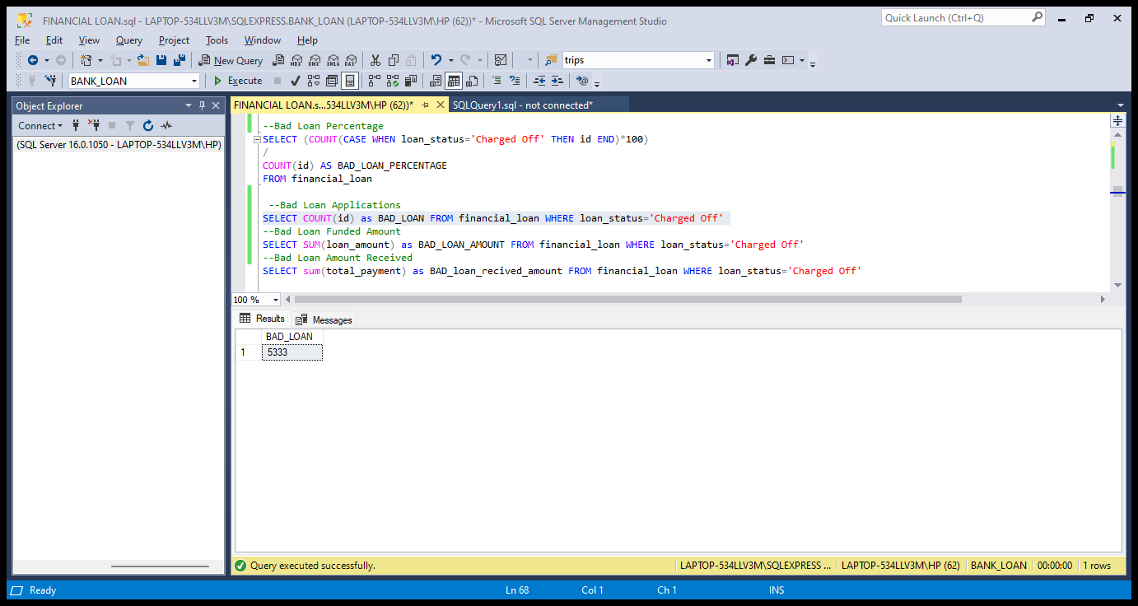

**Bad Loan Funded Amount**

SELECT SUM(loan_amount) as BAD_LOAN_AMOUNT FROM financial_loan WHERE loan_status='Charged Off'

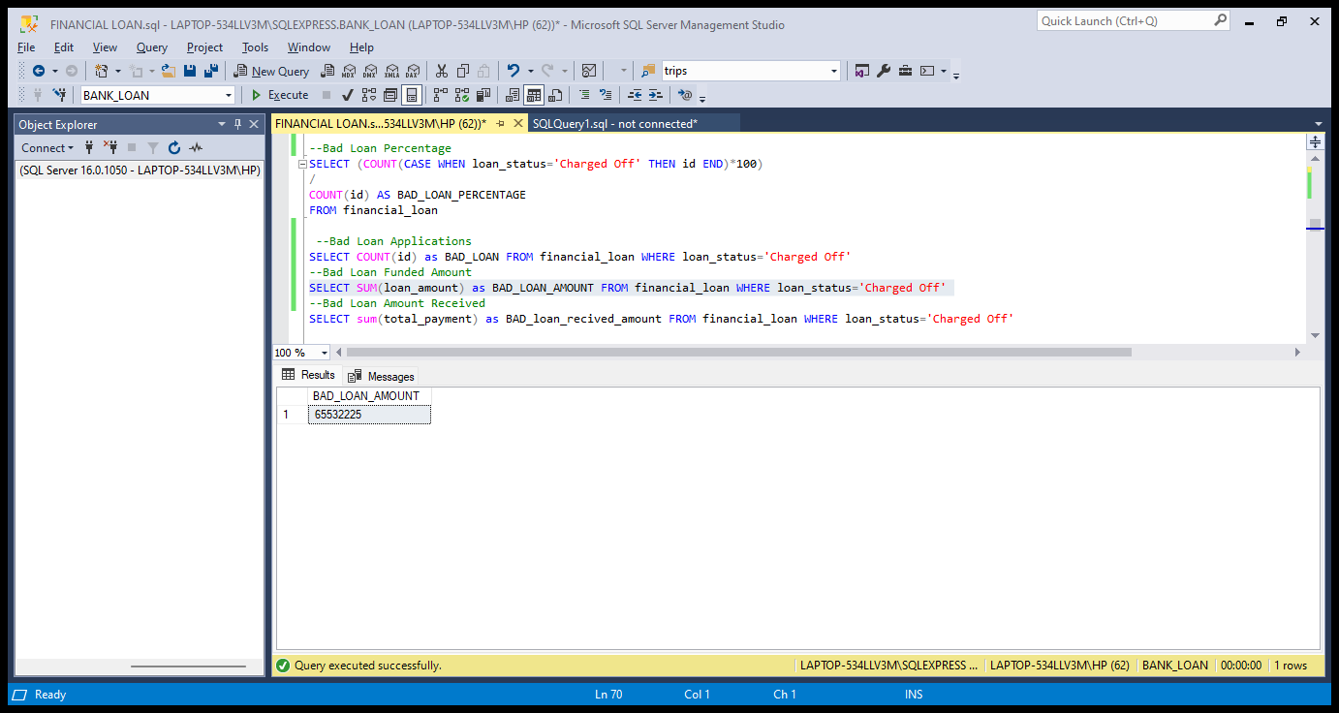

**Bad Loan Amount Received**

SELECT sum(total_payment) as BAD_loan_recived_amount FROM financial_loan WHERE loan_status='Charged Off'

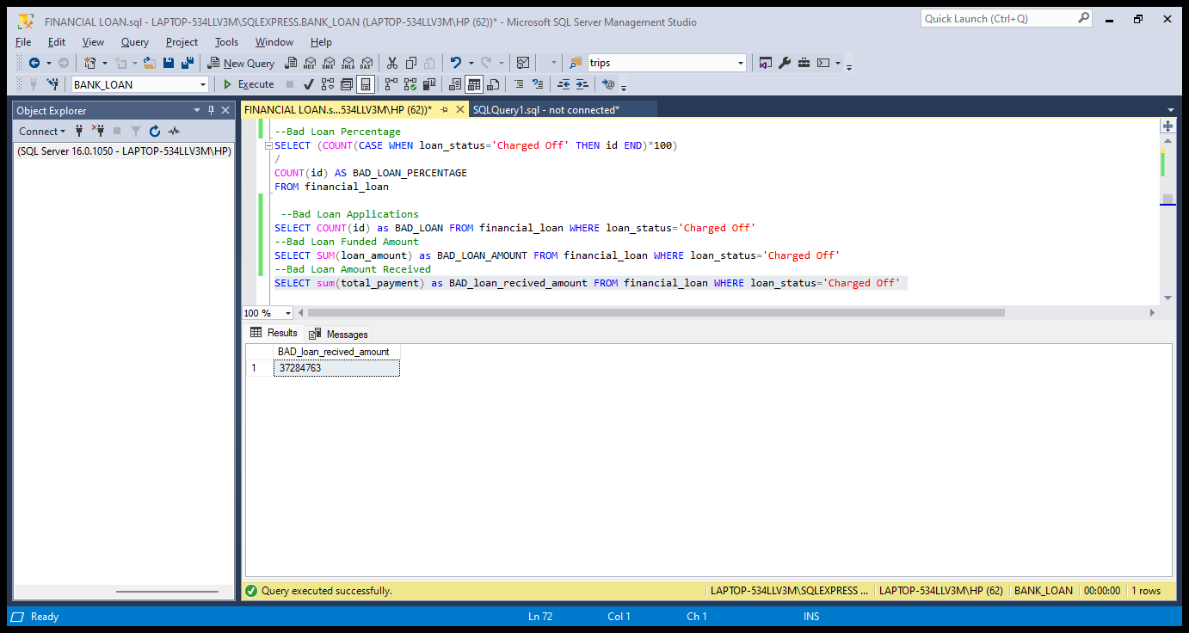

**LOAN STATUS**

SELECT loan_status,

COUNT(id) AS TOTAL_APPLICATION,

SUM(total_payment) AS TOTAL_RECIVABLE,

SUM(loan_amount) AS TOTAL_LOAN_AMOUNT,

AVG (int_rate*100) AS INTEREST_RATE,

AVG(dti*100) AS DTI

FROM financial_loan

GROUP BY loan_status

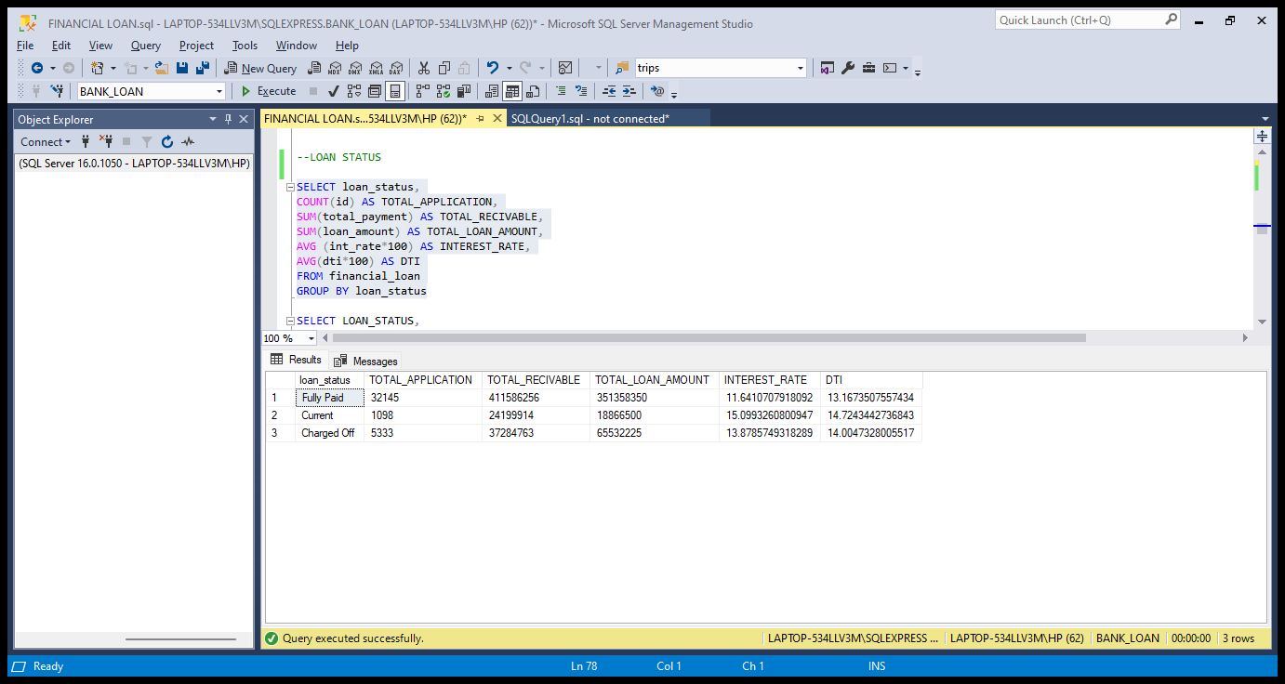

SELECT LOAN_STATUS,

SUM(total_payment) AS MTD_TOTAL_AMOUNT_RECEIVED,

SUM(loan_amount) AS MTD_TOTAL_FUNDED_AMOUNT

FROM financial_loan

WHERE MONTH(issue_date)=12

GROUP BY loan_status

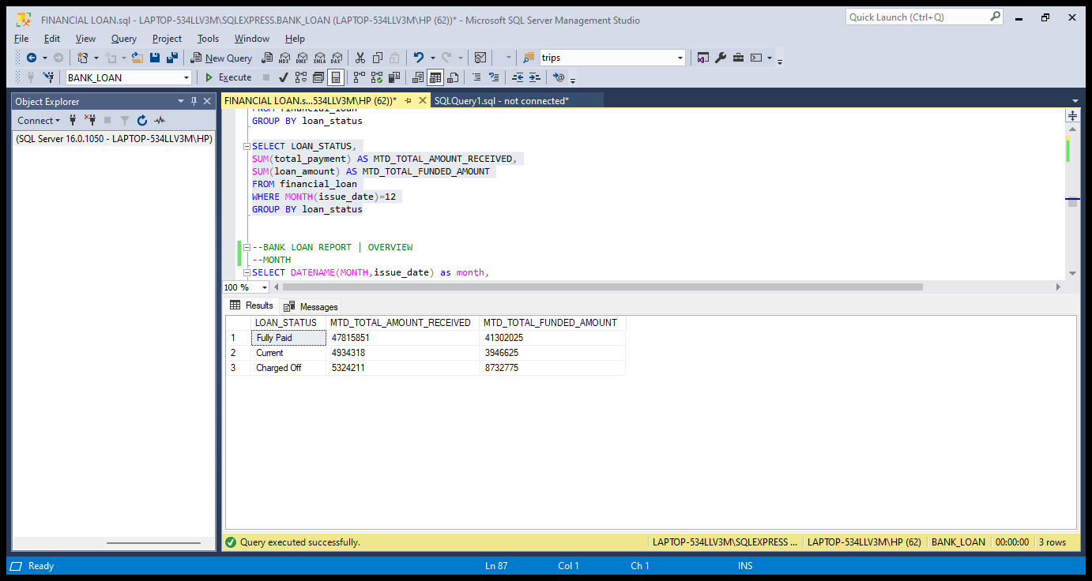

1. **BANK LOAN REPORT | OVERVIEW**

**MONTH**

SELECT DATENAME(MONTH,issue_date) as month,

COUNT(id) AS TOTAL_APPLICATION,

SUM(loan_amount) AS TOTAL_FUNDED_AMOUNT,

sum(total_payment) as total_recivable

FROM financial_loan

group by DATENAME(MONTH,issue_date)

order by TOTAL_APPLICATION desc

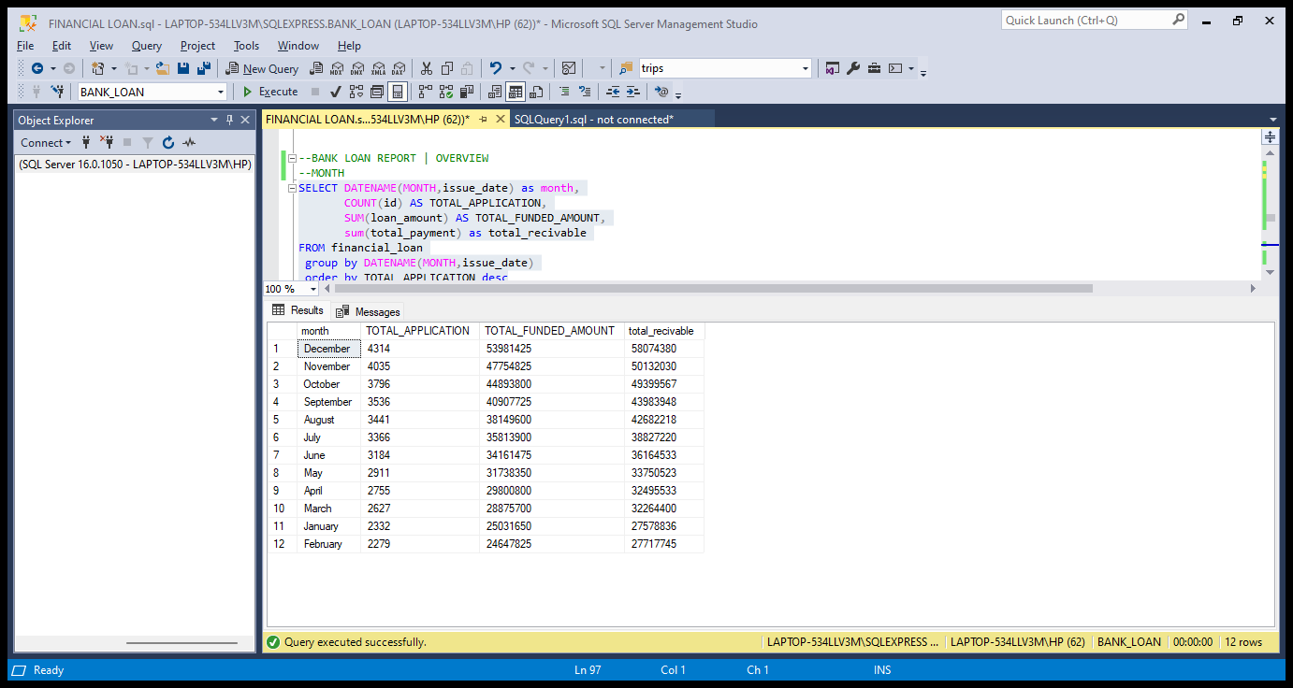

**STATE**

SELECT address_state,

COUNT(id) AS TOTAL_APPLICATION,

SUM(loan_amount) AS TOTAL_FUNDED_AMOUNT,

sum(total_payment) as total_recivable

FROM financial_loan

group by address_state

order by TOTAL_APPLICATION desc

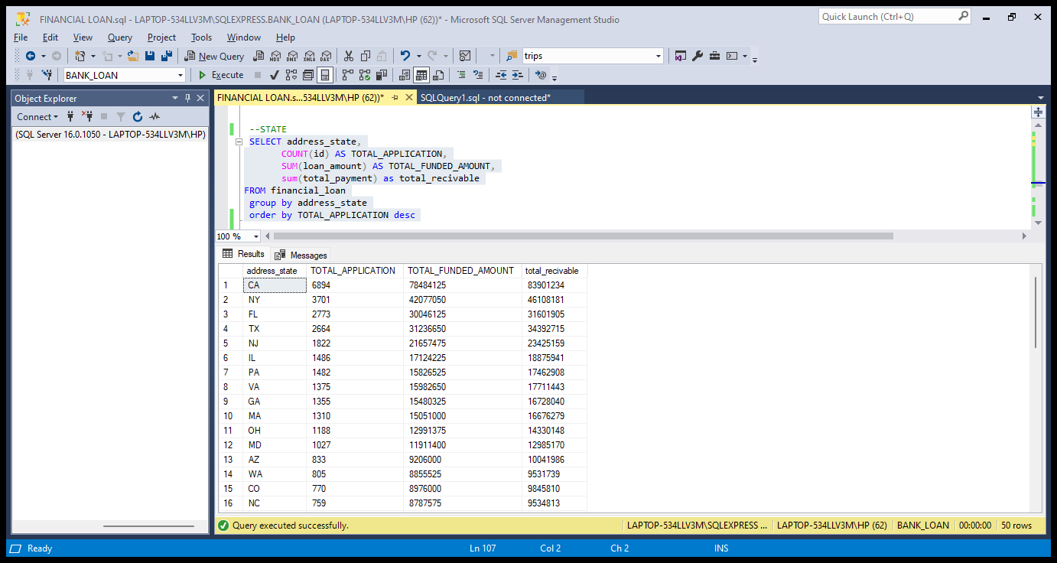

**TERM**

SELECT

term AS Term,

COUNT(id) AS Total_Loan_Applications,

SUM(loan_amount) AS Total_Funded_Amount,

SUM(total_payment) AS Total_Amount_Received

FROM financial_loan

GROUP BY term

ORDER BY term

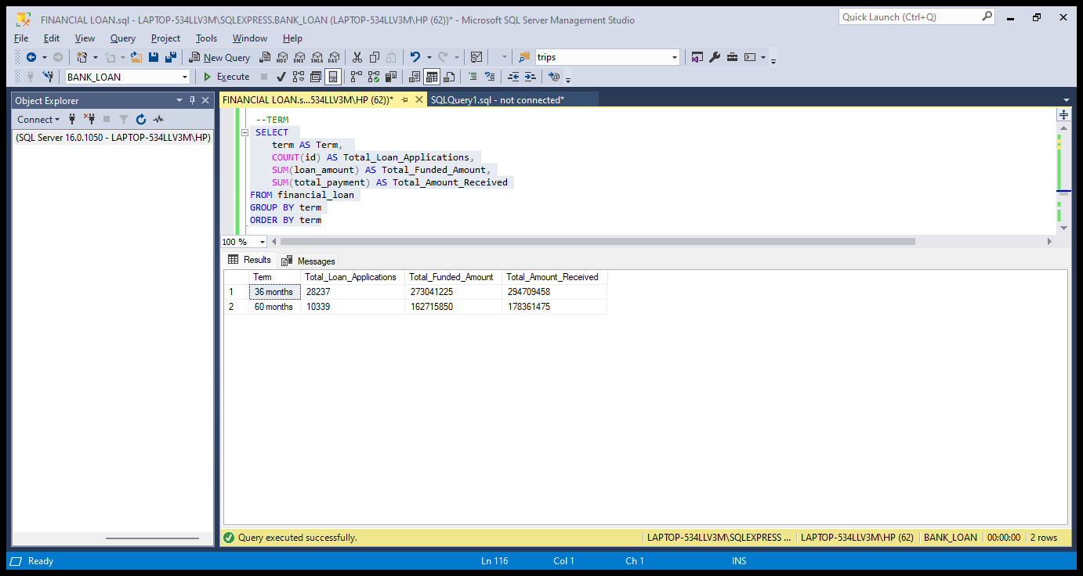

**EMPLOYEE LENGTH**

SELECT emp_length,

COUNT(id) AS TOTAL_APPLICATION,

SUM(loan_amount) AS TOTAL_FUNDED_AMOUNT,

sum(total_payment) as total_recivable

FROM financial_loan

group by emp_length

order by emp_length

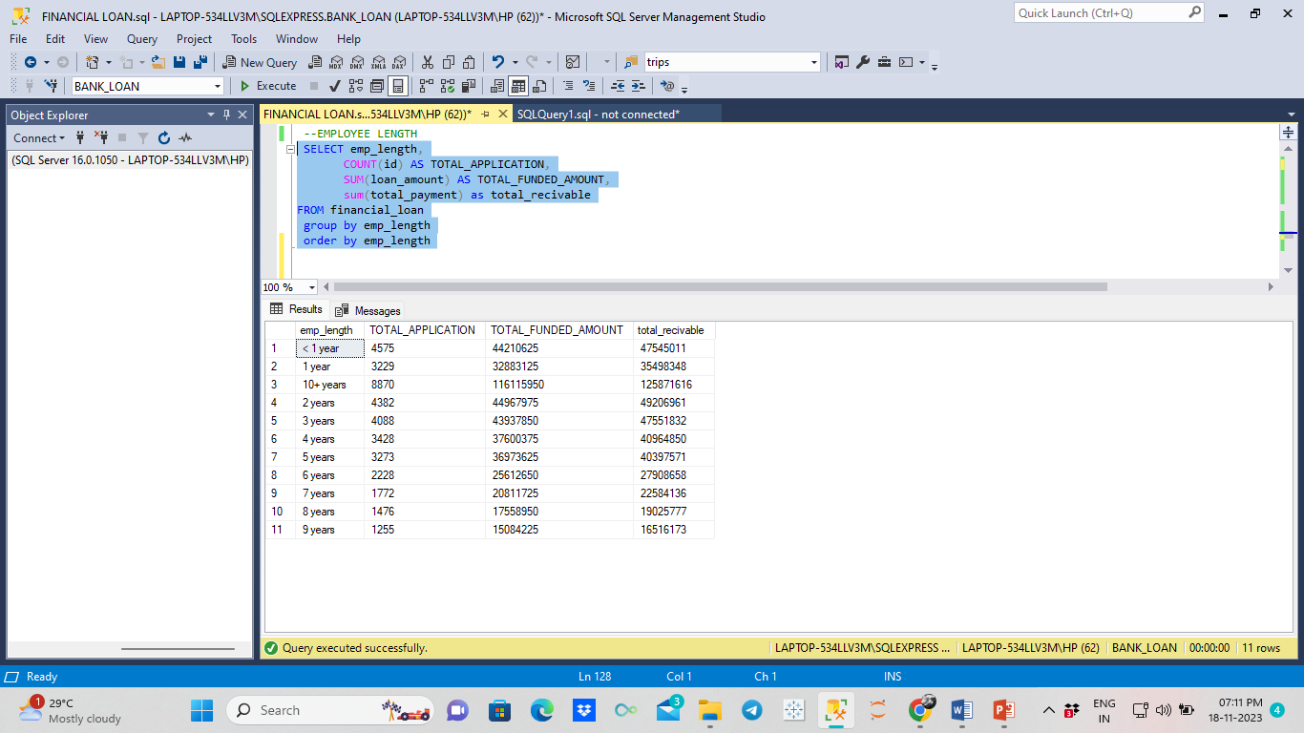

**PURPOSE**

SELECT purpose,

COUNT(id) AS TOTAL_APPLICATION,

SUM(loan_amount) AS TOTAL_FUNDED_AMOUNT,

sum(total_payment) as total_recivable

FROM financial_loan

group by purpose

order by TOTAL_APPLICATION desc

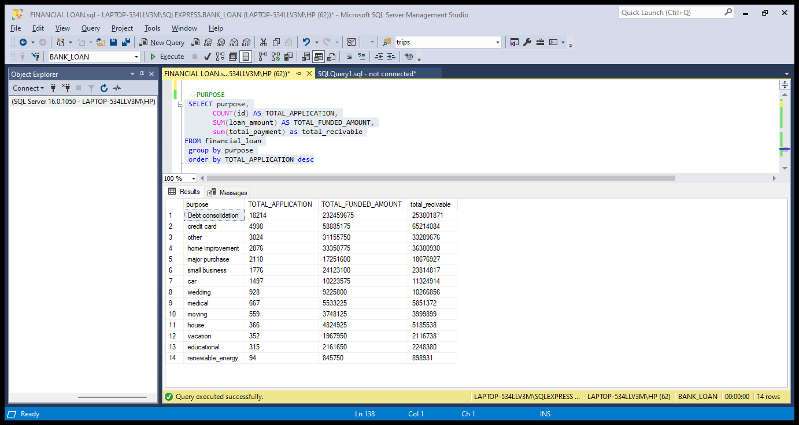

**HOME OWNERSHIP**

SELECT home_ownership,

COUNT(id) AS TOTAL_APPLICATION,

SUM(loan_amount) AS TOTAL_FUNDED_AMOUNT,

sum(total_payment) as total_recivable

FROM financial_loan

group by home_ownership

order by TOTAL_APPLICATION desc

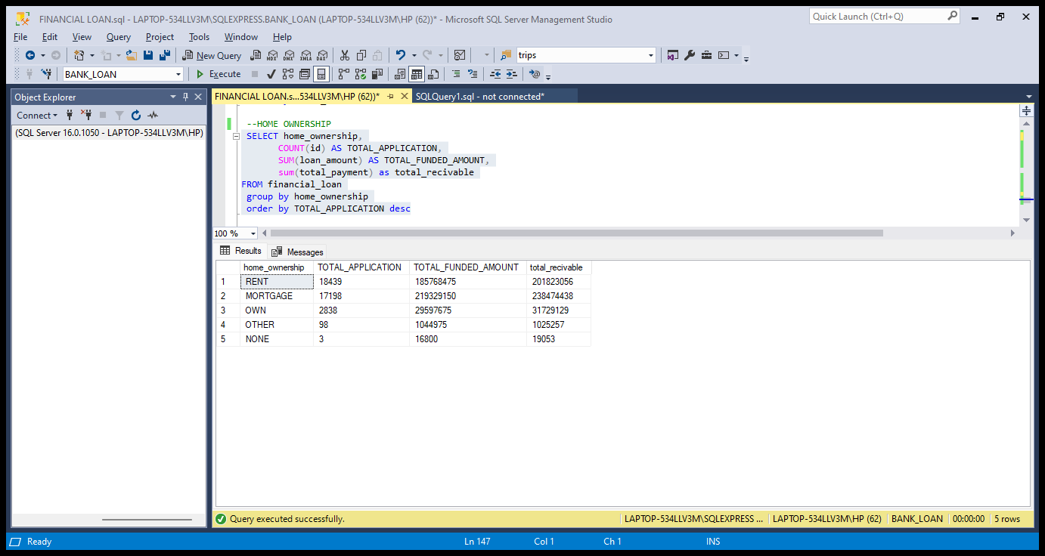

**GRADE**

SELECT grade,

COUNT(id) AS TOTAL_APPLICATION,

SUM(loan_amount) AS TOTAL_FUNDED_AMOUNT,

sum(total_payment) as total_recivable

FROM financial_loan

group by grade

order by TOTAL_APPLICATION desc

